1. first you can install git in your window ,setup the git application
2. open your cmd type text,

* git –version
* configure Git
* git config –global user.name ”your name”
* Git config –global user. Email “[you@example.com](mailto:you@example.com)”

1. Open Visual studio code next select folder or open folder.
2. Create a new file in that folder next write any test in that file.txt than save it.
3. Next open new terminal
4. navigate to your project folder like, i.e.cd path/to/your/folder
5. Type this command.

* git version
* git status
* git init
* git log
* git add my.txt
* Git add .
* git commit -m "this is my commit"

1. Next the pushing the file into the Git hub

* first you can login into git hub
* next create a new repository
* Next copy the https link in that repository

1. Come back to VS code run cmd terminal type next command

* Git remote add orgin paste here copied https link
* Git push –u orgin master
* Than it can transfer the file into git hub

**Definitions of commands**

**Git version** -> Shows installed git version

**Git status** ->Shows current repo status (changes, staged files, untracked files).

**Git init** -> Creates a new Git repository in the current folder.

**Git log** -> shows commit history.

**Git add file.txt** -> Adds only file.txt to staging (prepare for commit).

**Git add .** -> adds all changes in the current folder to staging.

**Git commit –m “this my commit”** - > Saves (commits) the staged changes with a message “this my commit”

**Git remote add origin <https link>** -> Connects your local repo to remote repo (Git hub/Git lab).

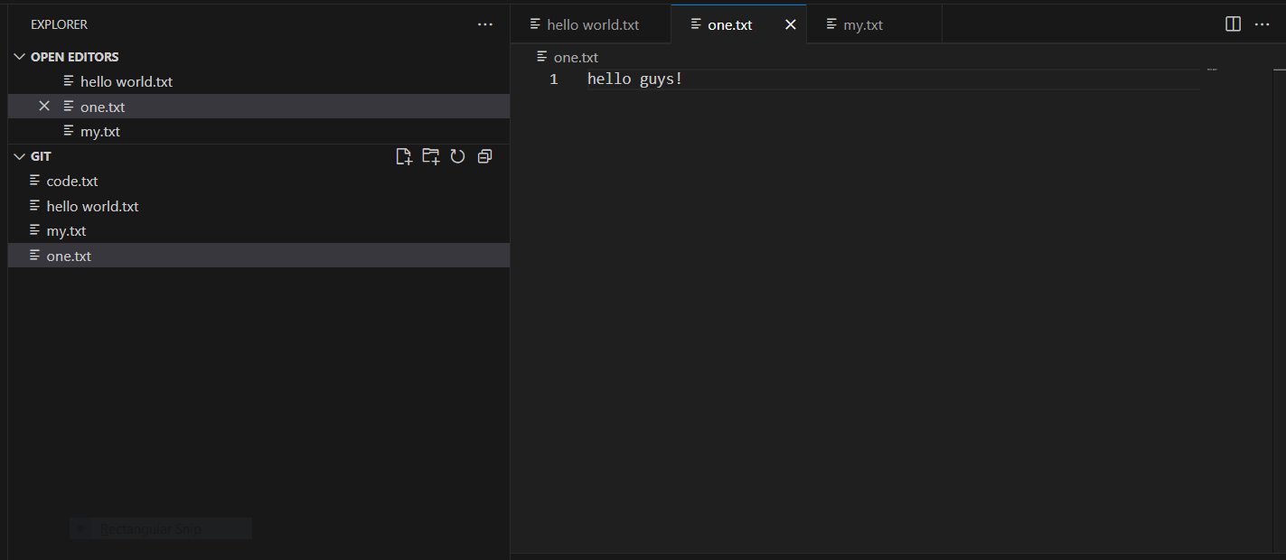**Git push -u origin master** -> Uploads (pushes) your local commits to the remote repo’s master branch.

